Talend Studio from Cloud:

Before starting Talend, you need to install java version 17 or java version 8. You can download java here: https://www.oracle.com/java/technologies/javase/jdk17-archive-downloads.html

1. Use university email address to register for an account here, but don’t sign up too early—you’ll only have a two-week free trial:
https://www.qlik.com/us/trial/talend-data-fabric

2. Once your account is activated, go to download:
https://app.us.cloud.talend.com/portal/download

3. Select the compatible type and version and download Talend Studio:
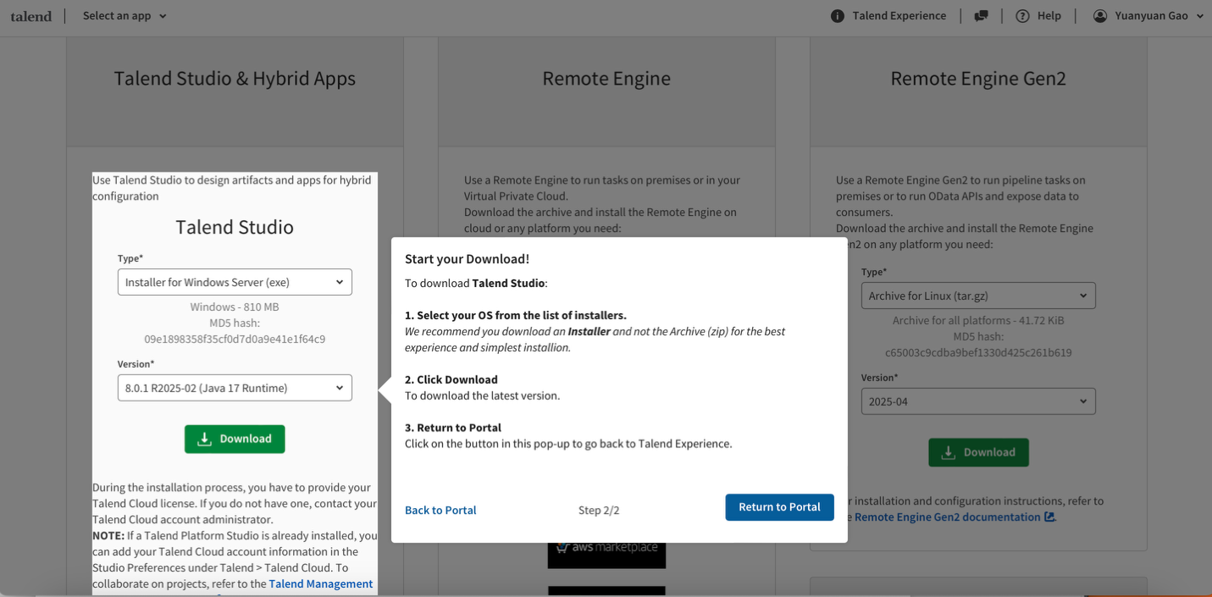

6. Once you finished downloading and installing, please open the studio:
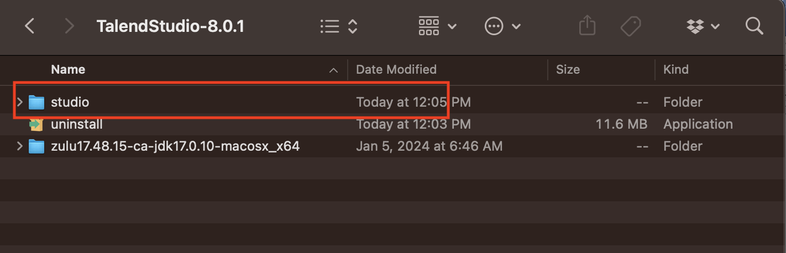

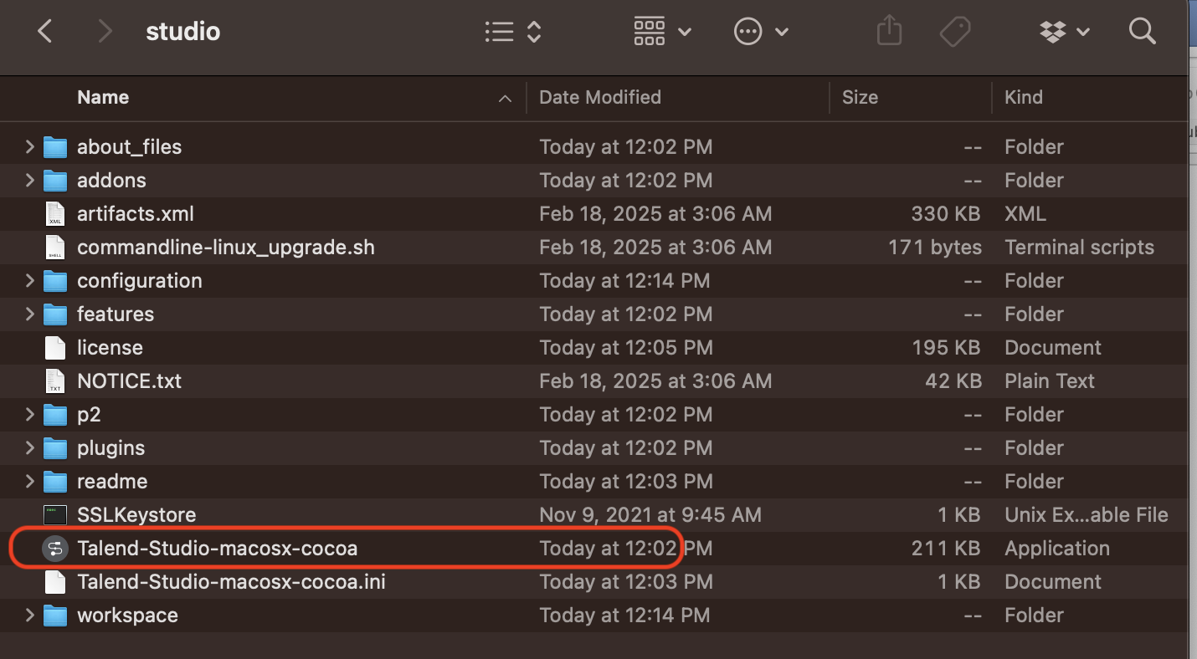

7. First “login with Talend Cloud” and then Select “login with other mode”:

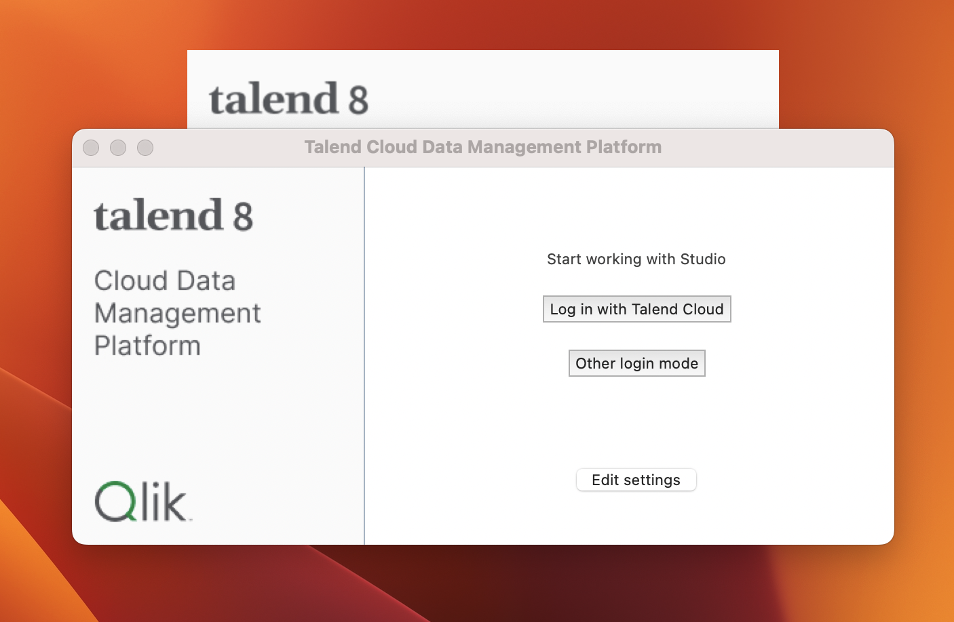

8. Use your registered email to login: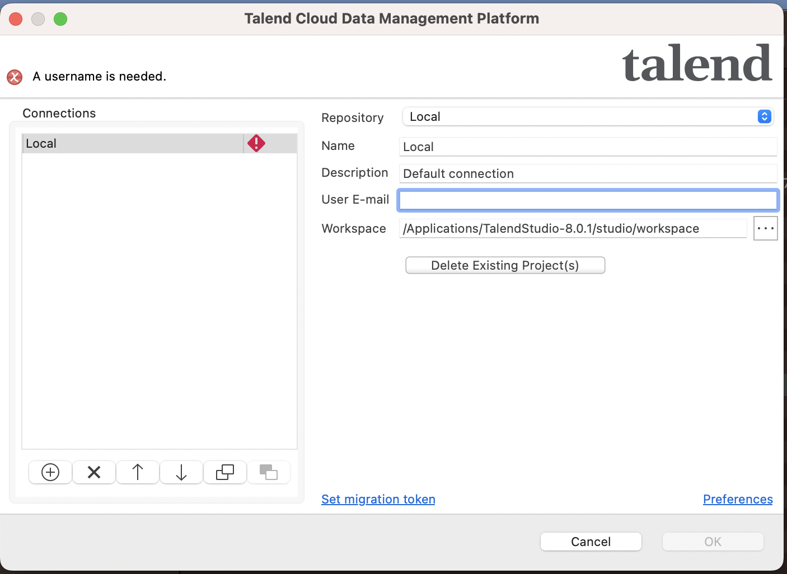

We will start from here.

